Simulator Requirement Specification

|  |  |
| --- | --- |
| Department Name | PRODUCTION DEPARTMENT |
| Class | FINAL YEAR |
| Semester | 7 |
| Subject Name | INDUSTRIAL AUTOMATION & ROBOTICS |
| Experiment No. | 1 |
| Experiment Name | BUZZER INTERFACING ON ATMEGA 2560 MICROCONTROLLER |

Version History

|  |  |  |  |  |
| --- | --- | --- | --- | --- |
| Sr. No. | Version Number | Created By | Approved By | Date |
| 1 | v1.0 | Sushant More | Mr.V.D.Kamble | DD/MM/YYYY |
|  |  |  |  |  |

Detailed Requirement Specification

|  |  |  |  |
| --- | --- | --- | --- |
| **Req. ID** | **Visual Entity Required** | **Requirement Description** | **Comments** |
| REQ1 | START SIMULATION BUTTON | Start the simulation | On starting simulation the buzzer must start and stop for the defined time in code |
| REQ2 | Diagram | - | - |
| REQ3 | Code section | Editable | As time is edited in code same must be reflected in output |

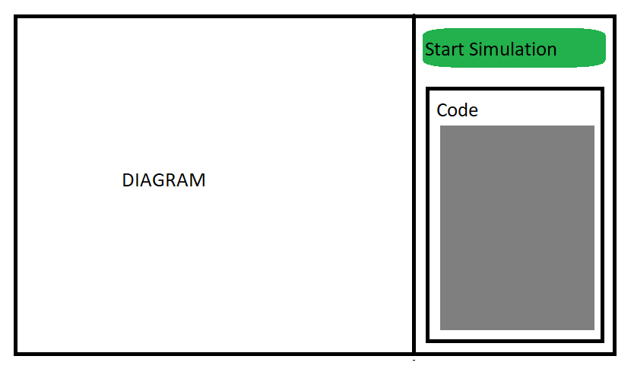

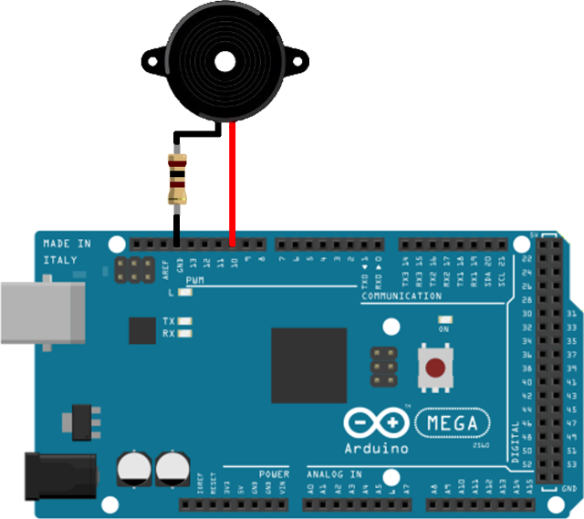

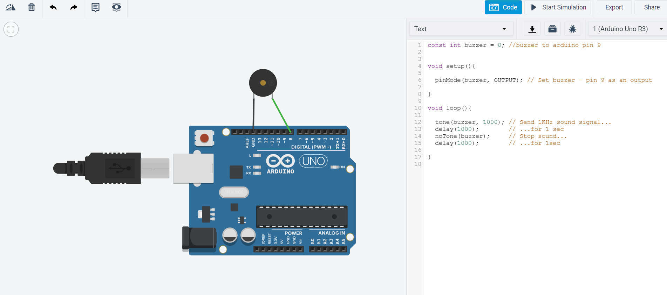

CODE

const int buzzer = 9; //buzzer to arduino pin 9

void setup(){

pinMode(buzzer, OUTPUT); // Set buzzer - pin 9 as an output

}

void loop(){

tone(buzzer, 1000); // Send 1KHz sound signal...

delay(1000); // ...for 1 sec

noTone(buzzer); // Stop sound...

delay(1000); // ...for 1sec

}

REF:

1. <https://create.arduino.cc/projecthub/SURYATEJA/use-a-buzzer-module-piezo-speaker-using-arduino-uno-89df45>